You are invited to a Book Launch Party!

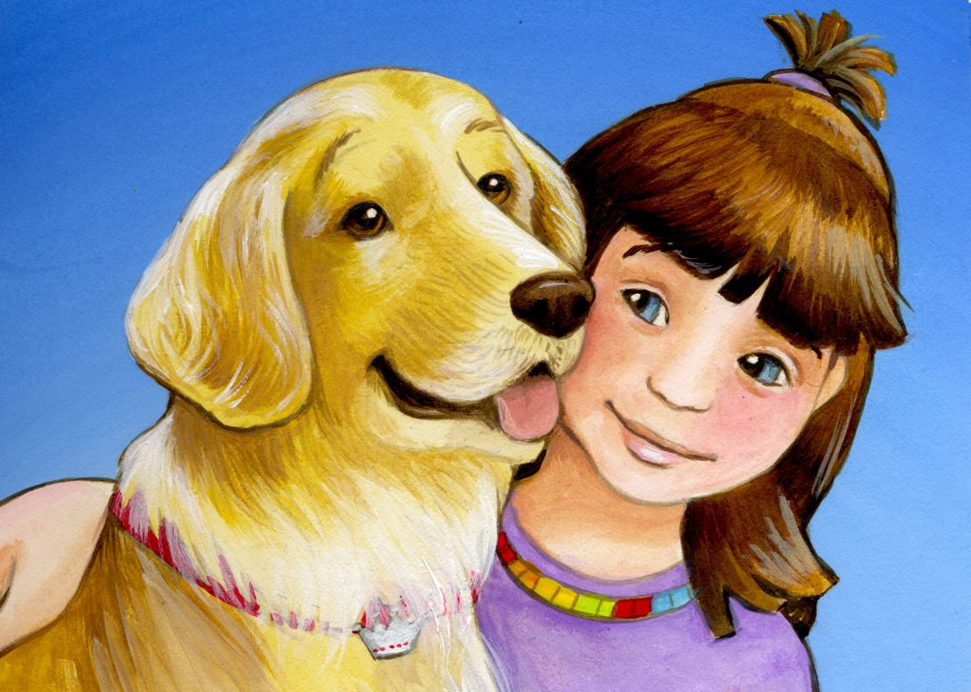Treasure’s Gift

By Laurie Hanson

Sunday, October 2, 2016

2:00 pm – 5:00 pm

5951 145th Lane NW, Ramsey, MN

Book signing by the author

Meet the illustrator, Darcy Bell-Meyers

Refreshments will be served

A portion of the sale of each book will be donated to the Morris Animal Foundation, for its

Golden Retriever Lifetime Study for the prevention of cancer in dogs and humans.

Visit LaurieHansonBooks.com for more info, or to purchase Treasure’s Gift